SUPPLEMENTARY INFORMATION

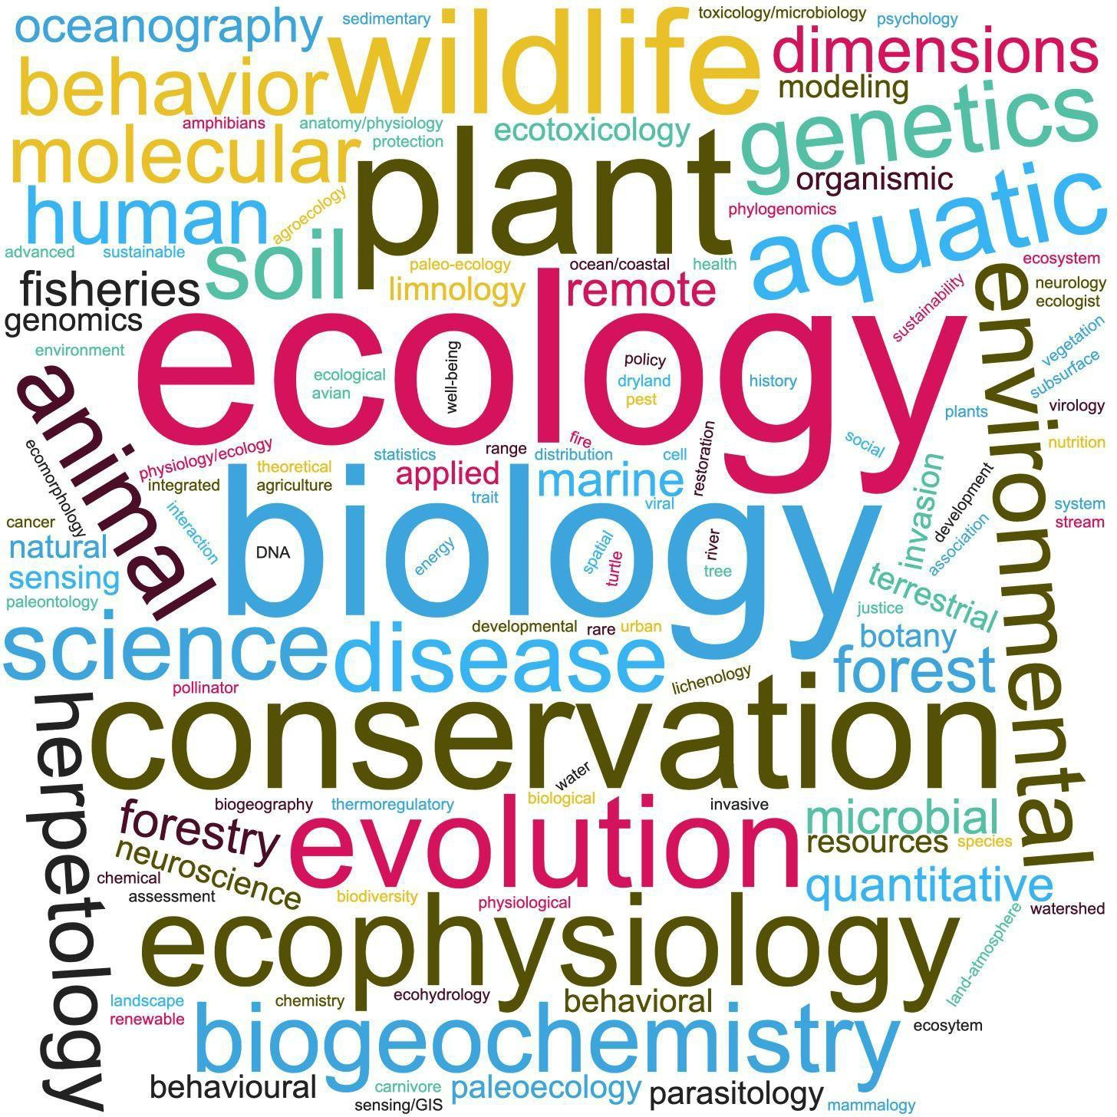

**Supplementary Figure S1**. Word cloud representation of respondents’ subfield of environmental biology. Bigger words indicate more use.

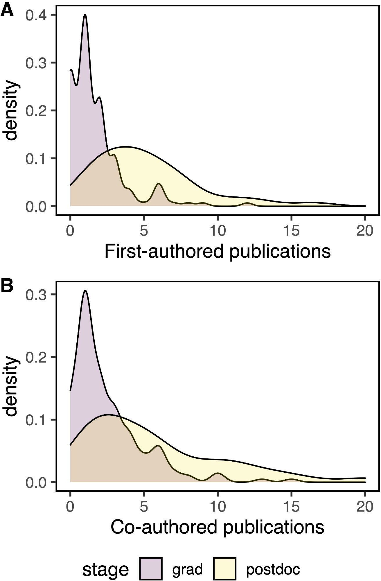

**Supplementary Figure S2**. Smoothed density of A) first-authored and B) co-authored publications of respondents separated by career stage. grad = graduate students and postdoc = postdoctoral scholars

**Supplementary Table S1.** Breakdown of survey respondent identity. We allowed respondents to choose their identity preference or NA if they were uncomfortable answering. Below the results are reported as a percentage of total responses within each career stage.

|  |  |  |
| --- | --- | --- |
|  | graduate students | postdoctoral scholars |
| **gender identity** |  |  |
| male | 24% | 37% |
| female | 73% | 61% |
| non-binary or other | 3% | 3% |
|  |  |  |
| **BIPOC** |  |  |
| yes | 24% | 9% |
| no | 76% | 91% |
|  |  |  |
| **first-generation college** |  |  |
| yes | 24% | 24% |
| no | 76% | 76% |
|  |  |  |
| **chronic condition** |  |  |
| yes | 24% | 9% |
| no | 76% | 89% |
|  |  |  |
| **English as a second language (ESL)** |  |  |
| yes | 18% | 23% |
| no | 82% | 77% |

**Supplementary Table S2**. **Graduate student** results for Bayesian multiple regression of how years in school and identity affect publication output. Except for years in graduate school, all other variables are factorial and coded as 1 = trainee identifies or 0 = trainee does not identify as first generation, female, BIPOC, having a chronic condition, or having English as a second language (ESL). Variables with 80% or higher probability of being on the same side of zero as the estimate (PD sign match) are bolded. 95% CRI = 95% credible interval, ESS = effective sample size

|  |  |  |  |  |  |
| --- | --- | --- | --- | --- | --- |
| **Parameter** | **Estimate (as median)** | **95% CRI** | **PD sign match** | **Rhat** | **ESS** |
| Intercept | 1.22 | [-0.05, 2.53] | 99.9% | 1.000 | 29328 |
| **Graduate training (yrs)** | 0.52 | [0.35, 0.69] | 100% | 1.000 | 30430 |
| First generation | 0.44 | [-0.67, 1.54] | 78.7% | 1.000 | 25842 |
| Female | -0.03 | [-1.16, 1.02] | 51.9% | 1.000 | 28580 |
| BIPOC | -0.28 | [-1.41, 0.83] | 69.3% | 1.000 | 27527 |
| **Chronic condition** | -0.80 | [-1.97, 0.42] | 90.6% | 1.000 | 28402 |
| ESL | -0.35 | [-1.30, 0.64] | 76.0% | 1.000 | 30936 |

**Supplementary Table S3**. **Postdoctoral scholar** model results for Bayesian multiple regression of how years in training and identity affect publication output. Years spent as a graduate student and postdoctoral scholar are continuous, and all other variables are factorial and coded as 1 = trainee identifies or 0 = trainee does not identify as first generation, female, BIPOC, having a chronic condition, or having English as a second language (ESL). Variables with 80% or higher probability of being on the same side of zero as the estimate (PD sign match) are bolded. 95% CRI = 95% credible interval, ESS = effective sample size

|  |  |  |  |  |  |
| --- | --- | --- | --- | --- | --- |
| **Parameter** | **Estimate (as median)** | **95% CRI** | **PD sign match** | **Rhat** | **ESS** |
| Intercept | 5.11 | [-0.94, 11.21] | 94.7% | 1.000 | 17536 |
| **Graduate training (yrs)** | 0.33 | [-0.40, 1.03] | 81.9% | 1.000 | 20429 |
| **Postdoctoral training (yrs)** | 2.10 | [1.26, 2.91] | 100% | 1.000 | 18808 |
| First generation | -0.75 | [-0.67, 1.54] | 66.7% | 1.000 | 20795 |
| **Female** | -1.39 | [-1.16, 1.02] | 81.3% | 1.000 | 19018 |
| BIPOC | 1.41 | [-1.41, 0.83] | 70.1% | 1.000 | 19331 |
| Chronic condition | 1.58 | [-1.97, 0.42] | 77.5% | 1.000 | 21679 |
| ESL | -0.76 | [-1.30, 0.64] | 65.2% | 1.000 | 17617 |

**Supplementary Table S4**. Results for binomial multiple regression on yes/no responses among **graduate students** to the question “Has COVID-19 impacted your writing habits?” All estimates are in logit scale for ease of comparison. Variables with 80% or higher probability of being on the same side of zero as the estimate (PD sign match) are bolded.

|  |  |  |  |  |  |
| --- | --- | --- | --- | --- | --- |
| **Parameter** | **Estimate (as median)** | **95% CRI** | **PD sign match** | **Rhat** | **ESS** |
| Intercept | 1.45 | [-0.75, 1.10] | 61.9% | 1.000 | 23699 |
| Graduate training (yrs) | 0.03 | [-0.09, 0.16] | 69.9% | 1.000 | 23097 |
| **First generation** | 0.97 | [ 0.06, 1.92] | 98.6% | 1.000 | 21695 |
| **Female** | 0.43 | [-0.36, 1.24] | 85.5% | 1.000 | 21036 |
| **BIPOC** | 2.10 | [ 1.08, 3.33] | 100% | 1.000 | 16247 |
| Chronic condition | 0.36 | [-0.53, 1.32] | 78.4% | 1.000 | 20067 |
| **ESL** | -1.57 | [-2.27, -0.86] | 100% | 1.000 | 19004 |

**Supplementary Table S5.** Binomial multiple regression on yes/no responses among **postdoctoral scholars** to the question “Has COVID-19 impacted your writing habits?” All estimates are in logit scale for ease of comparison. Variables with 85% or higher probability of being on the same side of zero as the estimate (PD sign match) are bolded.

|  |  |  |  |  |  |
| --- | --- | --- | --- | --- | --- |
| **Parameter** | **Estimate (as median)** | **95% CRI** | **PD sign match** | **Rhat** | **ESS** |
| Intercept | -0.19 | [-1.34, 0.91] | 63.6% | 1.000 | 19942 |
| **Postdoc training (yrs)** | 0.27 | [-0.04, 0.58] | 96.2% | 1.000 | 15493 |
| First generation | 0.39 | [-0.82, 1.65] | 73.3% | 1.000 | 20064 |
| **Female** | 0.69 | [-0.38, 1.80] | 90.0% | 1.000 | 19673 |
| BIPOC | 0.53 | [-1.42, 2.49] | 70.6% | 1.000 | 16519 |
| **Chronic condition** | -1.23 | [-2.75, 0.32 | 94.8% | 1.000 | 20118 |
| **ESL** | -1.36 | [-2.83, 0.00] | 97.7% | 1.000 | 13960 |

**Supplementary Table S6**. Five of eight non-binary/other gendered respondents indicated that the COVID-19 pandemic impacted writing habits. They generally reported having less productivity and less motivation.

|  |  |  |  |  |  |
| --- | --- | --- | --- | --- | --- |
| **Question** | **Much less** | **Less** | **Neutral/ no change** | **More** | **Much more** |
| Amount of time for writing | 1 | 0 | 1 | 3 | 0 |
| Writing productivity | 0 | 5 | 0 | 0 | 0 |
| Writing motivation | 3 | 1 | 1 | 0 | 0 |